**Digital Signal Processing**

**Project**

**Basic techniques for processing audio files**

* **Data**
* We have ele.wav file which is the elephant song.
* We use wavfile.read for reading and we get fs and data.
* Fs = 22050
* Order = 20
* Data = array of int16 containing the frequencies.

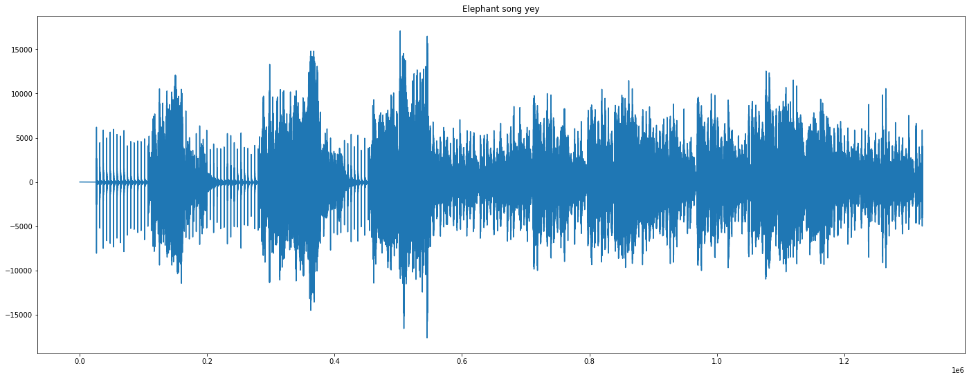

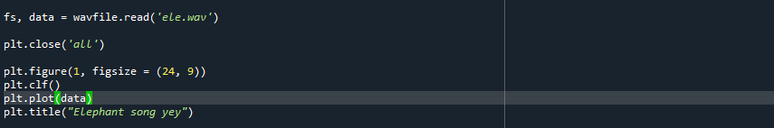

* **In the second part of the code, we find the effects of lowpass filtering of a signal with different cutoff frequencies: 6000, 3400 and 2000 Hz**
* we plot 3 lowpass filters of IIR type, order 20, starting from Butterworth equivalents

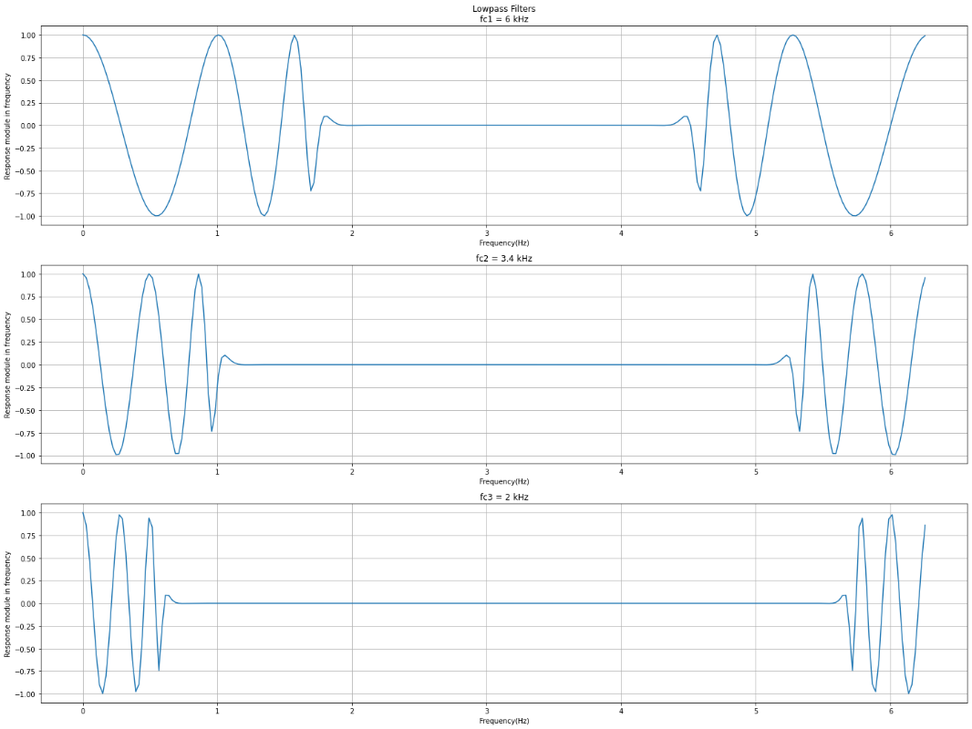

* **In the third part of the code, we are filtering our song (y1,y2,y3.wav)**

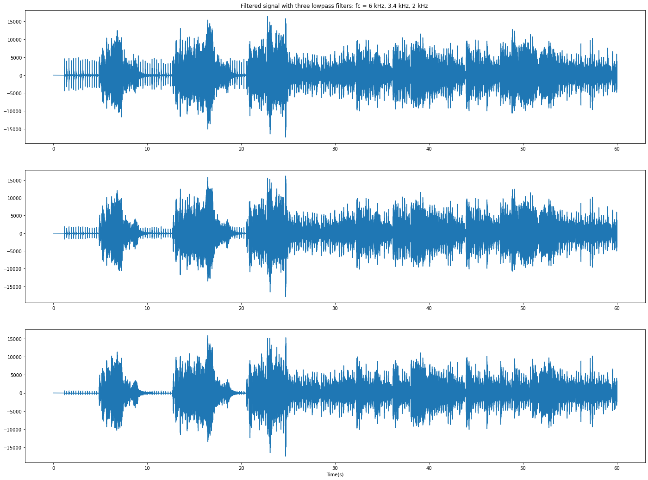

* **Notes:**
  + The frequency range of sound sounds is concentrated to low frequencies, while that of unsound sounds concentrates at higher frequencies.
  + Fricative consonants have, in general, spectral concentration at the highest frequencies in relation with the other phonemes.
* **In the fourth part of the code, we decimate and interpolate our song modifying the playback speed. (yi.wav and yd.wav)**

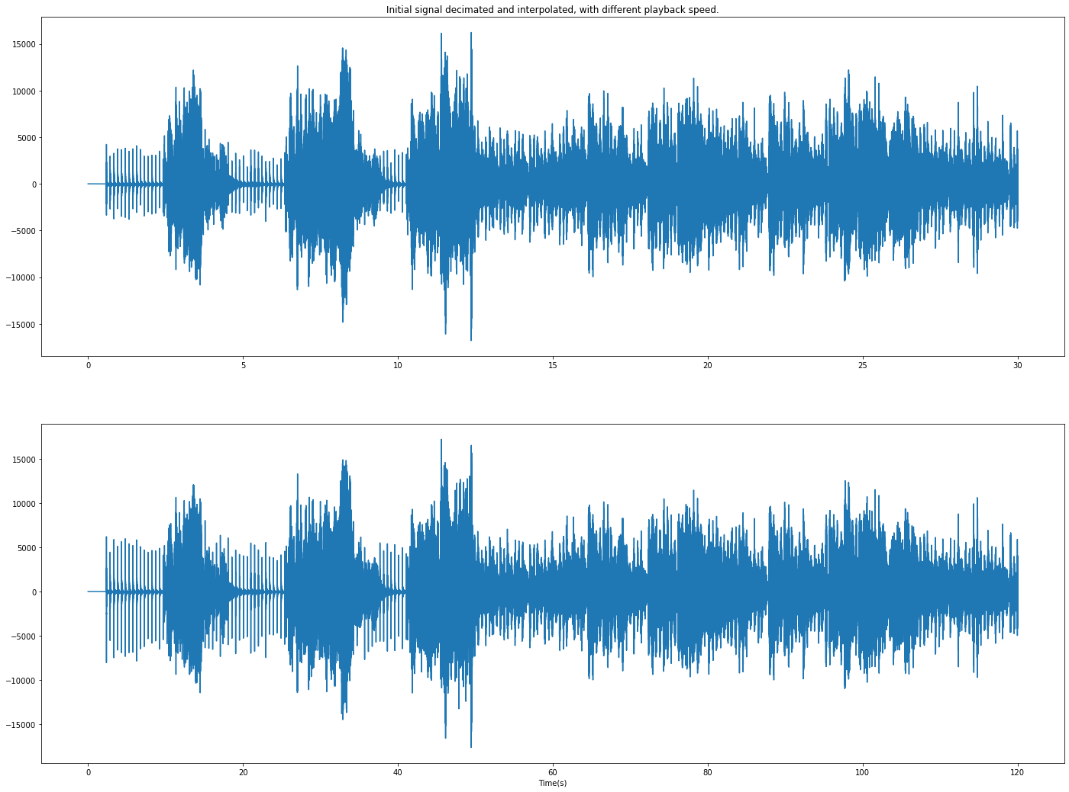

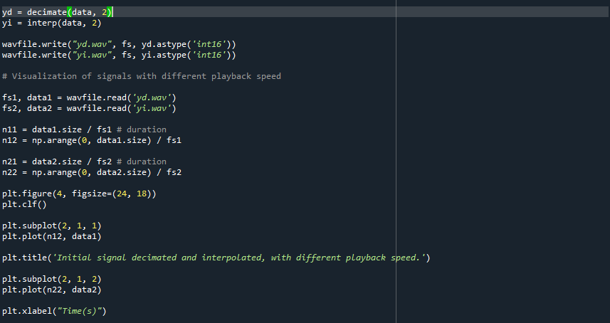

* **In the fifth part of the code, we simulate a reverb / echo using a comb filter, recursive (IIR) using two filter types:** 
  + **Notch (ynotch.wav)**

* + **Peak (ypeak.wav)**

